Knox Uniting Church Cluster
Sunday June 8th 2025 – (RCL: Pentecost Sunday. Year C)
Sermon (reflection) by Russell Croxford at Bayswater Uniting Church
Bible passages: Psalm 104:24-30. Romans 8:14-17. Acts 2:1-4. (NRSV)

‘The Energy of the Spirit’
It’s Pentecost Sunday today which means our focus is on the Holy Spirit. If I was to do a survey today of this room, seeking your definitions of the Holy Spirit, I’m sure I would get a lot of different answers! Even in scripture, the Spirit is understood, experienced and described in a multitude of different ways and with many different images. So where do we start?

Today I’m going to pick one image and focus on the idea of the Holy Spirit as ‘energy’.

In our passage from Acts 2, we read about the events that took place on that Day of Pentecost when the disciples had gathered and experienced the Holy Spirit in quite a dramatic and powerful way. It could be described as a violent experience of the Spirit. This was not a gentle, quiet, reflective worship experience. Quite the opposite. A couple of weeks ago, when I was preaching about Jesus giving the gift of his Spirit to his followers (John 14:25-27), I used the image of the gentle white dove to express the peaceful and peace-giving nature of the Spirit. But in Acts 2, the Spirit seems anything but peaceful.


Both wind and fire are associated here with the Spirit. Neither are peaceful images as such. That’s why I’ve chosen this image (Pixabay Free Images). I like this image because it seems to depict the day of Pentecost very well, with many people – not just the disciples, of all colours, nations and backgrounds being touched by the power of the flames blowing all around them.


For many years I loved to windsurf.
(Pixabay image). That’s not me in the picture by the way! I wish! What was so amazing about windsurfing was power of the wind in the sail, which you could feel through your hands and arms. And the best thing was to experience how that wind-power, once harnessed, was converted to incredible movement through the water.

It’s a great illustration of the Holy Spirit, as a strong wind, carrying so much energy, and potentially being transferred to us if we harness the Spirit in our lives. In other parts of the bible, the idea of wind or breath is used to speak of God’s Spirit. In Greek the word is ‘pneuma’ and in Hebrew it’s ‘Ruach’ and this ‘breath of God’ is not only powerful, but also life giving. There is the energy of life in the breath of God. It’s another great image.

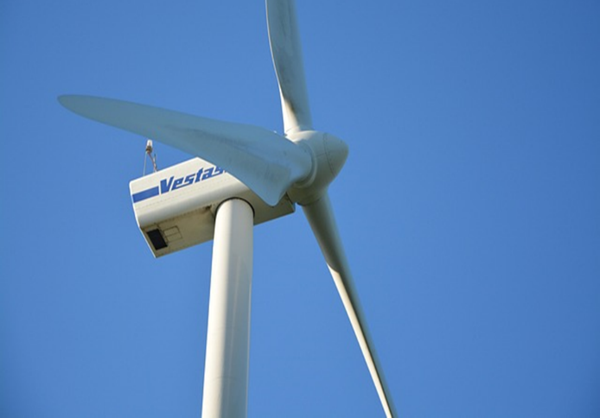
My son Bradley is an environmental engineer. He works for a renewable energy company, and he is involved in a big project in NSW that’s developing a windfarm. Now I realise there are different opinions about windfarms. And it’s a real shame that the energy debate has become so political in recent times. But I’m sure we can all marvel at the way these huge rotor blades catch the wind and drive a turbine to produce a massive amount of electricity.
There is so much energy in the wind. It’s another way to think of the energy of the Spirit. (Pixabay image)

As I reflected on the Pentecost story in today’s reading, the question I tossed around in my mind was, what does this energy of the Spirit actually do in us, and in the world? I came up with a few ideas about that.

It’s an energy that mobilizes.
Once upon I time I was a science teacher. Some of it I can still remember. I do still remember Newton’s three laws. His first law is the law of inertia, which states that an object will remain stationary or at the same speed unless acted on by an external force. Maybe that law has a spiritual application! When we think about the disciples, following the death of their leader, they were rather ‘paralysed’ by all the horrible events they had witnessed, and had thus become somewhat ‘stationary’ - until, that is, an experience of God’s Spirit mobilizes them into action. It jolts them out of their inertia and gets them moving.

It’s an energy that empowers
One of the rather amazing aspects of the Pentecost Day events was the way those disciples started speaking in all the different languages and then went out to preach and witness with courage and confidence. It was an energy that empowered, enabled and equipped them to do what they otherwise didn’t have the capacity to do.

It’s an energy that unites
Most of us know what it’s like to be a foreigner in a different country where everyone speaks a different language to you and you feel left out - excluded. I’ve been to Korea a couple of times with my wife Sophie, and I can tell you that not much English is spoken over there. So, whenever I did hear someone speaking English, I tuned in and it gave me a feeling of connection. All those foreigners, visiting Jerusalem for the Pentecost festival suddenly heard people speaking their own language. Suddenly they were all connected. Through language, the Holy Spirit was uniting, rather than dividing by race or background.

It's an energy that creates
Let’s consider now another of our readings today, Psalm 104. This is a beautiful Psalm of praise that talks about the wonder of creation. In this Psalm there is very strong connection between God’s Spirit and his creating of all living things and indeed the whole of creation. As the psalmist writes, “When you send your Spirit, they are created, and you renew the face of the earth” (Ps 104:30)

It is worth noting on this point, that God’s Spirit has always been in the world. In that sense, the Holy Spirit didn’t really ‘come at Pentecost’ as most would say. The Holy Spirit has always been in the world and in people. That’s evidenced in Psalms like this one. Maybe at Pentecost it was more about a group of people being open and ready to encounter, in a new way, what had been there all the time. Something to think about!

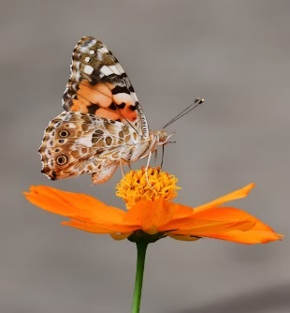
I love this picture because it captures a living creature and a living plant – both exquisite in their colour, detail and beauty. Just a tiny part of God’s creation. We could literally look at thousands of such images, like we might see on a David Attenborough documentary! God is so creative in nature. God’s creative Spirit is in all of creation. The natural world is one of the most amazing evidences of God’s presence through his creative Spirit.

It's an energy that gives life
This follows on from the previous one. In verse 29 of our Psalm we read, “When you take away their breath, they die and return to the dust”. There’s that word ‘breath’ again, symbolic of the blowing wind of the spirit of God - a spirit of life. God breathes his spirit of life into all living things. He breathed his spirit of life into that group on the Day of Pentecost, and he breathes his spirit of life into all of us today.

It's an energy that subdues the chaos.
In verse 26 the Psalmist mentions ‘the leviathan’ frolicking in the depths. The leviathan is often mentioned in the Old Testament. This is a mythical sea monster whose very existence evokes terror and panic. It is also a symbol of chaos since its home is the ocean – a place of chaos in the minds of those early writers. Yet even the chaos of monsters in the ocean is under God’s control in this Psalm. The leviathan is subdued and tamed.

That makes me think of another science teaching moment. There’s another law called ‘The second law of thermodynamics’. It states that all systems will evolve towards disorder and chaos, unless there is the input of energy to bring order to the chaos. That sounds like a description the whole world we live in doesn’t it…always evolving towards disorder and chaos! The world needs the energy of God’s spirit to bring a new order of peace and love into it. And we can be the carriers of that energy of God’s Spirit – which leads to my final point…

An invitation to participate in this energy.
Our third reading today comes from Romans 8. In this passage Paul reminds us that we are God’s own sons and daughters because we have received a Spirit of adoption (v15). The invitation here is to enjoy being intimately involved with God as our ‘Abba Father’ (v15) by allowing ourselves to be ‘controlled’ by the Spirit (v9) and ‘led’ by the Spirit (v14).

I remember one of my theology lecturers once saying that he always desired that his own spirit would flow with God’s Spirit. That thought always stayed with me. Do I choose to flow with God’s Spirit? Or do I flow against God’s Spirit? Is my own human energy working in sync with the energy of the Holy Spirit. Or is my energy trying to do something different? If I’m flowing with the energy of the Holy Spirit then I am being a part of all that God is doing. I’m being part of his energy in the world.

